# Facebook banks on virtual reality as the future of socialising

By **Victoria Turk,** *New Scientist*, 20 April 2017

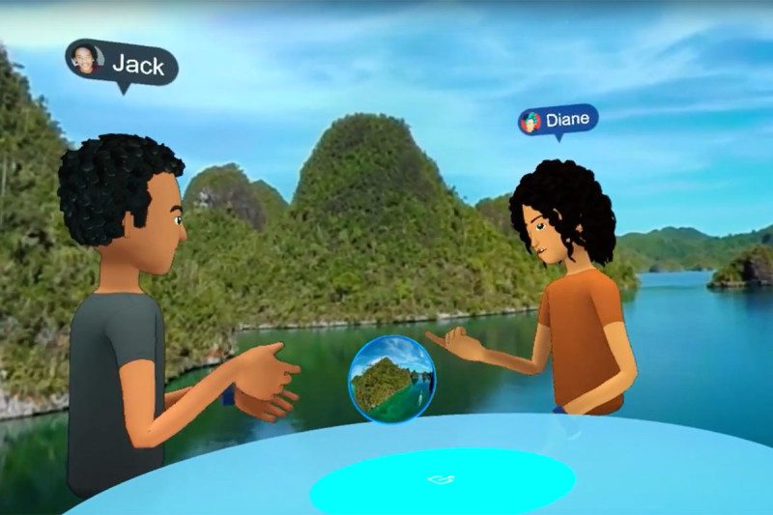

Socialising in Facebook Spaces via VR

You finally managed to get everyone together in one place. Friends you haven’t seen for ages, scattered around the world, smile and talk to each other across a table – a virtual table, in a virtual world, seen through a [virtual reality headset](https://www.newscientist.com/article/mg21829225.700-virtual-reality-get-your-head-in-the-game/). This is the future of socialising, according to Facebook.

The social network announced several new products at its F8 Developer Conference in San Jose this week, with a strong focus on virtual and [augmented reality.](https://www.newscientist.com/article/mg23231044-600-augmented-reality-set-to-overtake-vr-as-new-apps-go-live/)

Facebook Spaces, its new VR app, lets you chat with friends in a 3D virtual environment. It’s the first real glimpse of how Facebook plans to make virtual reality a social tool [after buying Oculus VR in 2014.](https://www.newscientist.com/article/dn25304-facebook-and-oculus-social-medias-extra-dimension/)

“VR is a technology that gives us something no other technology has before – a magical feeling of presence, the sense that we’re really there together even when we’re apart,” said head of social VR Rachel Franklin as she announced the app.

**Cartoon you**

To create this feeling, Facebook Spaces lets you customise a cartoon avatar to represent you in the virtual world based on one of your Facebook photos. You can bring multiple people into the virtual space at the same time and chat as you usually would, using Oculus Touch controllers to move your avatar’s arms.

The VR app also draws on the wealth of content connected to your Facebook profile. You can overlay 360 images or videos from your Facebook feed onto the virtual space to plunge you and your avatar friends into a personalised environment, and flick through 2D photos with them.

Friends who don’t have Oculus Rift- and the headset is pretty expensive at around £500 – can be added to the conversation through video chat on Facebook Messenger. There’s also an MS Paint-style drawing tool so you can doodle in the air, though the focus of the app is on just hanging out and chatting.

This kind of social VR is essentially a “fancier version of Skype”, says [Antonia Hamilton](http://www.antoniahamilton.com/), a social neuroscientist at University College London. VR offers an advantage over video messaging, she says, because it can let us more easily communicate using nonverbal cues such as facial expressions and gestures.

**Wooden**

But consumer headsets don’t capture motion or expressions well enough to make it look realistic in the virtual world. “Without capturing faces, you get VR characters which look very wooden and people often don’t like them,” says Hamilton.

In addition to virtual reality, Facebook is banking on [augmented reality](https://www.newscientist.com/article/mg23231044-600-augmented-reality-set-to-overtake-vr-as-new-apps-go-live/) playing a role in our future communications. While its new AR tools are little more than Snapchat-like filters for your smartphone camera, the company clearly envisages a transition to wearable AR devices. “We want glasses, eventually contact lenses, that look and feel normal but let us overlay all kinds of information and digital objects on top of the real world,” said CEO Mark Zuckerberg at the conference.

With developments in AI, augmented reality will ultimately be so good that you won’t be able to tell augmented visuals from reality, says [Hao Li](http://www.hao-li.com/Hao_Li/Hao_Li_-_about_me.html) at the University of Southern California.

But there needs to be a hardware revolution before social VR and AR can become mainstream, he says. Headsets are still [expensive and uncomfortable](https://www.newscientist.com/article/mg23230952-400-virtual-reality-no-one-is-actually-buying-2016s-hottest-tech/), and cause some users [to feel dizzy or nauseous](https://www.newscientist.com/article/2115648-posture-could-explain-why-women-get-more-vr-sickness-than-men/). “Until this has been solved, I find it hard to believe that the content would be so good and so engaging that people would want to use it on a daily basis,” says Li.

And it remains to be seen how much social value these tools can really provide. At one rather poignant moment in the conference, Zuckerberg demonstrated using AR to add a second coffee cup into an image of a dining table – “so it doesn’t look like you’re having breakfast alone”.

**Tasks**

**1. Decide if these sentences are true or false according to the text. If they are false, correct them so that they can become true.**

1. The main objective of Facebook Spaces is to allow participants to interact in a 3D virtual environment.
2. Only those Facebook friends with Oculus Rift can participate in this VR application.
3. All the experts interviewed think headsets capture nonverbal cues like facial expressions realistically.
4. The success of these social applications depends essentially on the development of the hardware.
5. The social value of these tools is still not known.

**2. Explain these new words; you have sometimes the solutions in the text. It is also possible to add a synonym:**

1. **Banks on (heading)**: ................................
2. **Scattered (l.3)**: ..............................
3. **Customise (l.15)**: ..............................
4. **AR (l. 36)**: ..........................................
5. **Dizzy (l. 46)**: ......................................

**3. In-class discussion:**

The article finishes with this sentence: “Zuckerberg demonstrated using AR to add a second coffee cup into an image of a dining table – “so it doesn’t look like you’re having breakfast alone”. **Do you think this is what we are soon going to experience in the near future, the need to add a second cup of coffee to pretend we are not alone?**

**4. Translate into English:**

1. En el futuro, la gente se podrá socializar en un mundo virtual donde todo se verá a través de un casco de realidad virtual.

....................................................................................................................................................................................................................................................................................................

2. La realidad virtual es una tecnología que nos da la sensación mágica de que estamos juntos incluso cuando estamos separados.

....................................................................................................................................................................................................................................................................................................

3. Los avances en IA cuentan con la realidad aumentada, que jugará un papel importante en nuestras futuras comunicaciones.

....................................................................................................................................................................................................................................................................................................

Video activity: [**https://www.youtube.com/watch?v=JXYmpqdhHzg**](https://www.youtube.com/watch?v=JXYmpqdhHzg)

1:29-3:50

We can go from taking a still photo to mapping out a whole 3D scene. So, this actually is what was taken from a 2D**……………STILL IMAGE…………** in our office in Seattle. And from the still photo we constructed a 3D scene. And now, because it's a 3D scene we can **……pan………AROUND…………**. How crazy is that? Crazy. All right. We can change lighting, we can turn the lighting down, we can move the lighting from the front of the room to the back, and you can add erm... **…………ALL KIND OF EFFECTS……………** You know we can fill the room up with water if we want. Again, it's got the depth right. You can add a lot of bouncy balls, we’re fond of bouncy balls and we can fill the room up with **………SKIttles………………** Because the future is delicious.

We also have some of the best computer vision and **……object……RECOGNISON WORK……………** in the world. So that's going to help you identify different things in the scene to help you surface relevant effects that you want to **…………CHECK OUT……………**. So, you're going to **………TAP………………** on the coffee mug and we're going to service effects that are relevant to coffee. It's steam, you can add a second coffee mug so it looks like you're not drinking, they're not having breakfast alone. You even tap on the wine bottle and you can add an information card right that shows that shows erm...what the **…vintage……ADVANTAGES………………** of the wine is and you know what the **…………RATing……………** is and maybe where to get it or maybe in the future even a link to buy it.

So, here's an example of a father playing an augmented reality game with his kids in the waiting room at the doctor's office. We're using the table in the waiting room as the the game board for a **……TOWER…DEFENSE…GAME……………** and the kids can kind of slap the bad guys before they get to you.

You know, this is actually a piece of Facebook headquarters and you know without augmented reality this actually just **………LOOKS……like…………** a blank wall but when you're in augmented reality you get this beautiful **…………PIECE……of art………** not just a painting on the wall but it **……looks like……IT HAS……………** the whole space. Now, one of the things that I've always wanted to do is erm…is leave notes for friends in different places. I'm so talking about sharing a note to tell your friend **……………WHAT…THE BEST SPECIAL IS………**, right next to the sign of the special for the restaurant. And long-term all the work that we're doing here is going to go into glasses that we all want. It's all the same technology and this is another step on the **…………PATH……………** there.